AVIAT AIRCRAFT INC.

AIRPLANE FLIGHT MANUAL

MODEL PITTS S-2SP AIRPLANE

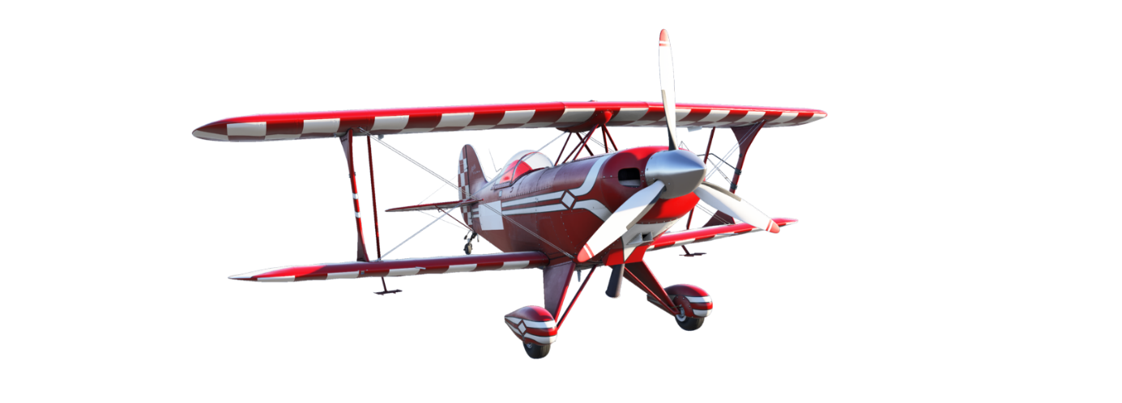

PAGE INTENTIONALY LEFT BLANK

OVERALL DIMENSIONS
Wing Span: | 20 ft. (6.1m)
Length: | 17 ft 9 in (5.5m)
Height: | 6 ft 5 in (1.9m)

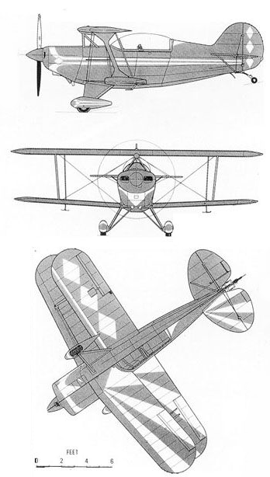
Figure 1-1 Three View

INTRODUCTION
This Airplane Flight Manual contains 10 4 Sections, and includes the material required to be furnished to the pilot by FAR Part 23. It also contains supplemental data supplied by Aviat Aircraft Inc.
Section 1 provides basic data and information of general interest. It also contains definitions or explanations of symbols, abbreviations, and terminology commonly use.

DESCRIPTIVE DATA

ENGINE
Number of Engines: | 1
Engine Manufacturer: | Textron Lycoming
Engine Model Number: | AEIO-540-EXP
Engine Type: | Normally aspirated,  Direct-drive, air-  Cooled, horizontally-  opposed, fuel injected,  aerobatic with inverted  oil, six-cylinder engine  with 588 cu. in  displacement.
Horsepower Rating &  Engine Speed: | 310HP @  2800RPM

PROPELLERS

Standard
Manufacturer: | Hartzell
Model Number: | HC-C3YR-4AX
Number of Blades: | 3 Composite
Diameter Maximum  Minimum | 80 inches (2.03 m)  78 inches (1.98 m)
Propeller Pitch settings:
High:  Low: | 32° to 34°  11° + or - .1° @  30 inch station.
Propeller Type: | Constant speed,  Hydraulically actuated,  Counter balanced with  Hartzell governor,  Approved for aerobatic flight.

Optional
Optional propeller installed in new aircraft at Aviat Aircraft per TC, also for retrofit when installed in accordance with serialized Aviat Aircraft Kit.
Manufacturer: | MT-Propeller
Model Number: | MTV-9-B-C/C190-18a
Number of Blades: | 3 Composite
Diameter Maximum  Minimum | 75 inches (190 cm)  75 inches (190 cm)
Propeller Pitch settings:
High:  Low: | 30° + or - 1°  13° + or - .2° @  26.18 in (6.5 cm)  station.
Propeller Type: | Constant speed and  Hydraulically actuated.

FUEL

Approved Fuel Grades (and Colors):
100 (Formerly 100/130) Grade Aviation Fuel (Green)
100LL Grade Aviation Fuel (Blue)

Fuel Capacity
Standard Tanks Normal Flight:
Total Capacity: | 35 US gal (132.5 L)
Total Capacity  main:  wing: | 20 US gal (75.7L)  15 US gal (56.8 L)
Total Useable: | 34 US gal (128.7 L)  During normal flight  conditions.

Standard Tanks Aerobatic Flight:
Total Capacity: | 20 US gal (75.7 L)
Total Capacity  main:  wing: | 20 US gal (75.7L)  0 US gal (0.0 L)
Total Useable: | 19 US gal (71.9 L)

WARNING NOTE
Do not perform low altitude aerobatics with less than ¼ tank of fuel in the main tank. Wing tank is for ferry use only.

MAXIMUM CERTIFIED WEIGHTS
Takeoff  Normal Category:  Aerobatic Category: | 1325 lbs (601.7 kg)  1250 lbs (567.0 kg)
Landing: | 1325 lbs (601.7 kg)
Baggage Compartment: | 20 lbs (9.01 kg)

WARNING NOTE
The maximum weight capacity for baggage area is 20 lbs (9.01 kg).
NO AEROBATIC MANEUVERS WITH BABBAGE.

STANDARD AIRPLANE WEIGHTS
Standard Empty Weight: | 950 lbs (430.9 kg)
Maximum Useful Load  Normal Category:  Aerobatics: | 375 lbs (215.5 kg)  300 lbs (136.1 kg)

SPECIFIC LOADINGS
Wing Loading  Normal:  Aerobatic: | 13.6 lb./sp.ft.  13 lb./sp.ft.
Power Loading  Normal:  Aerobatic: | 6.5 lb./hp  6.25 lb./hp

SYMBOLS, ABBREVIATIONS AND TERMINOLOGY

GENERAL AIRSPEED TERMINOLOGY AND SYMBOLS
KTCAS | Knots Calibrated Airspeed is indicated airspeed corrected for position and instrument error and expressed in knots. Knots calibrated airspeed is equal to KTAS in standard atmosphere at sea level.
KTIAS | Knots Indicated Airspeed is the speed shown on the airspeed indicator and expressed in knots.
KTAS | Knots True Airspeed is the airspeed expressed in knots relative to undisturbed air which is KTCAS corrected for altitude and temperature.
MPHCAS | MPH Calibrated Airspeed is indicated airspeed corrected for position and instrument error and expressed in mph. MPH calibrated airspeed is equal to MPHAS in standard atmosphere at sea level.
MPHIAS | MPH Indicated Airspeed is the speed shown on the airspeed indicator and expressed in knots.
MPHTAS | MPH True Airspeed is the airspeed expressed in mph relative to undisturbed air which is MPHCAS corrected for altitude and temperature.
V_{A} | Maneuvering Speed is the maximum speed at which you may use abrupt control travel.
V_{NO} | Maximum Structural Cruising Speed is the speed that should not be exceeded except in smooth air, then only with caution.
V_{NE} | Never Exceed Speed is the speed limit that may not be exceeded at any time.
V_{S} | Stalling Speed is the minimum steady flight speed at which the airplane is controllable.
V_{X} | Best Angle-of-Climb Speed is the speed which results in the greatest gain of altitude in a given horizontal distance.
V_{Y} | Best Rate-of-Climb Speed is the speed which results in the greatest gain in altitude in a given time.

GENERAL AIRSPEED TERMINOLOGY AND SYMBOLS
OAT | Outside Air Temperature is the free air static temperature. It is expressed in either degrees Celsius (formerly Centigrade) or degrees Fahrenheit.
Standard  Temperature | Standard Temperature is 59° F (15°C) at sea level pressure altitude and decreases by 3.6° F (2°C) for each 1000 feet of altitude.
Pressure  Altitude | Pressure Altitude is the altitude read from the altimeter when the altimeter’s barometric scale has been set to 29.92 inches of mercury (1013 mb).

ENGINE POWER TERMINOLOGY
BHP | Brake Horsepower is the power developed by the engine.
RPM | Revolutions Per Minute is engine speed.
MP | Manifold Pressure is a pressure measured in the engine induction system and is expressed in inches of mercury (Hg).

AIRPLANE PERFORMANCE AND FLIGHT PLANNING TERMINOLOGY
Demonstrated  Crosswind  Velocity | Demonstrated Crosswind Velocity is the velocity of the crosswind component for which adequate control of the airplane during takeoff and landing was demonstrated during certification tests. The value shown is not considered to be limiting.
Usable Fuel | Usable Fuel is the fuel available for flight planning.
Unusable Fuel | Unusable Fuel is the quantity of fuel that cannot safely used in flight.
GPH | Gallons per Hour is the amount of fuel (in gallons) consumed per hour.
NMPG | Nautical Miles Per Gallon is the distance (in nautical miles) which can be expected per gallon of fuel consumed at a specific engine power setting and/or flight configuration.
SMPG | Statute Mile Per Gallon is the distance (in statute miles) which can be expected per gallon of fuel consumed at a specific engine power setting and/or flight configuration.
g | g is acceleration due to gravity.

WEIGHT AND BALANCE TERMINOLOGY
Reference  Datum | Demonstrated is an imaginary vertical plane from which all horizontal distances are measured for balance purposes.
Station | Station is a location along the airplane fuselage given in terms of the distance from the reference datum.
Arm | Arm is the horizontal distance from the reference datum to the center of gravity (C.G.) of an item.
Moment | Moment is the product of the weight of an item multiplied by its arm.
Center of  Gravity | Center of Gravity is the point at which an airplane, or equivalent, would balance if suspended. It’s distance from the reference datum is found by dividing the total moment by the total weight of the airplane.
C.G. Arm | Center of Gravity Arm is the arm obtained by adding the airplane’s individual moments and dividing the sum by the total weight.
C.G. Limits | Center of Gravity Limits are the extreme center of gravity locations within which the airplane must be operated at a given weight.
Standard Empty Weight | Standard Empty Weight is the weight of a standard airplane including unusable fuel, full operating fluids and full engine oil.
Basic Empty Weight | Basic Empty Weight is the standard empty weight plus the weight of optional equipment.
Useful Load | Useful Load is the difference between ramp weight and the basic empty weight.
Maximum Ramp Weight | Maximum Ramp Weight is the maximum weight approved for ground maneuver. (It includes the weight of start, taxi and run up fuel.)
Gross (Loaded) Weight | Gross (Loaded) Weight is the loaded weight of the airplane.
Maximum Takeoff Weight | Maximum Takeoff Weight is the maximum weight approved for the start of the takeoff run.
Maximum Landing Weight | Maximum Landing Weight is the maximum weight approved for the landing touchdown.
Tare | Tare is the weight of chocks, blocks, stands, etc. used when weighing an airplane, and is included in the scale readings. Tare is deducted from the scale reading to obtain the actual (net) airplane weight.

CONVERSIONS
Miles Per Hour | X | 0.8690 | = | Knots
Nautical Miles | X | 1.852 | = | Kilometers
Feet | X | 0.305 | = | Meters
Inches | X | 0.0254 | = | Meters
Inches | X | 2.54 | = | Centimeters
Inches | X | 25.4 | = | Millimeters
Feet/Minute | X | 0.00508 | = | Meter/sec
Gallons (US) | X | 3.785 | = | Liters
Gallons (Imp) | X | 4.546 | = | Liters
Quarts (US) | X | 0.946 | = | Liters
Knots | X | 1.852 | = | km/h
PSI | X | 0.0689 | = | Bar
In.Hg | X | 33.86 | = | Mbar
lb | X | 0.453 | = | Kg
(°F-32) | X | 5/9 | = | °C
Knots | X | 1.1508 | = | MPH
Kilometers | X | 0.539 | = | Nautical mile
Meters | X | 3.281 | = | Feet
Meters | X | 39.37 | = | Inches
Centimeters | X | 3.937 | = | Inches
Millimeters | X | 0.03937 | = | Inches
Meter/sec | X | 197 | = | Feet/minute
Liters | X | 0.264 | = | Gallons (US)
Liters | X | 0.220 | = | Gallons (Imp)
Liters | X | 1.057 | = | Quarts (US)
Km/h | X | 0.539 | = | Knots
Bar | X | 14.51 | = | PSI
Mbar | X | 0.02953 | = | In.Hg
Kg | X | 2.205 | = | lb
°C | X | 9/5+32 | = | °F

PAGE INTENTIONALY LEFT BLANK

INTRODUCTION
Section 2 includes operating limitations, instrument markings, and basic placards necessary for safe operation of the airplane, its engine, standard systems and standard equipment. The limitations included in this section have been approved by the Federal Aviation Administration. When applicable, limitations associated with optional systems or equipment will be included in Section 9.

Note
The airspeeds listed in the Airspeed Limitation chart and the Airspeed Indicator Markings chart are based on Airspeed Calibration data shown in Section 5 with the normal static source, with the exception of the bottom of the green arc on the airspeed indicator. If the alternate static source is being used, ample airspeed margins should be observed to allow for the airspeed calibration variations between the normal and alternate static sources shown in Section 5.*
* Note from the author: Section 5 will not be covered!

Your Pitts is certified under FAA Type Certificate # A8S0 as Pitts Model S-2SP.

FUEL LIMITATIONS
Standard Tanks
Main Tank  Total Fuel:  Usable Fuel:  Unusable Fuel: | 20 US gal (75.7 L)  19 US gal (71.9 L)  1 US gal (3.7L)
Auxiliary Tank  Total Fuel:  Usable Fuel:  Unusable Fuel:  Unusable Fuel: | 15 US gal (56.8 L)  15 US gal (56.8 L)  0 US gallons level flight only (Normal Category)  15 US gallons level flight only (Aerobatic Category)

Note
The auxiliary tank is usable for cross country flight ONLY. Before draining auxiliary tank into main tank, burn enough fuel in main tank to hold auxiliary fuel or fuel will be transferred overboard.

WARNING
DO NOT PERFORM LOW ALTITUDE AEROBATICS WITH LESS THAN ¼ TANK OF FUEL IN MAIN TANK.

Approved Fuel Grades (and Colors):
100LL Grade Aviation Fuel (Blue)
100 (Formerly 100/130) Grade Aviation Fuel (Green)

PLACARDS
The following information is displayed in the form of composite or individual placards.
- In the view of the pilot on the left hand side of the cockpit fairing:
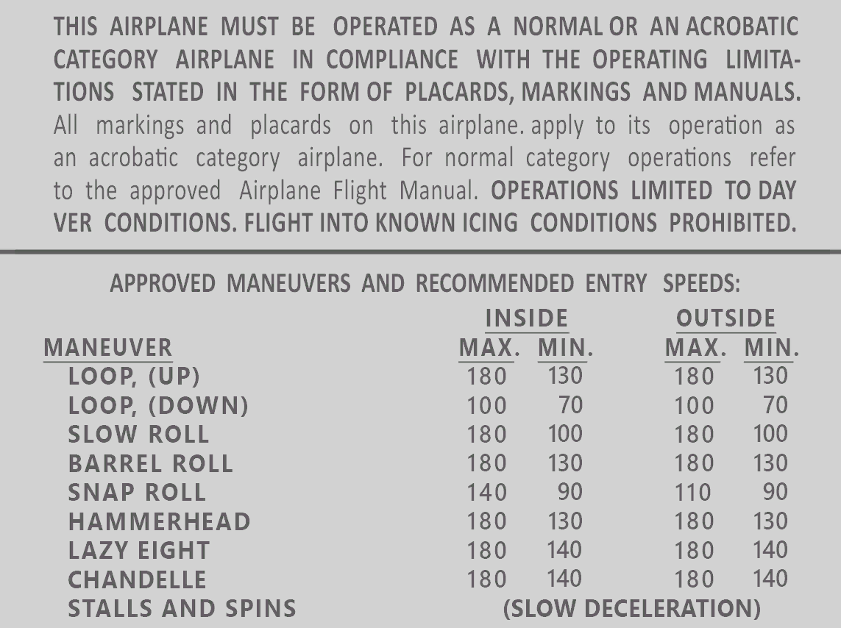
- At the fuel selector handle:
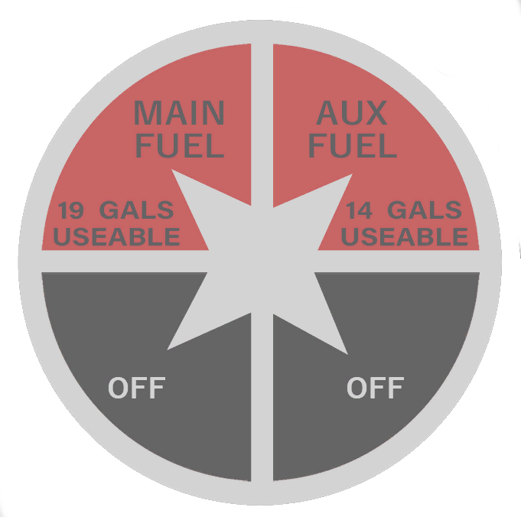
- Adjacent to airspeed indicator:
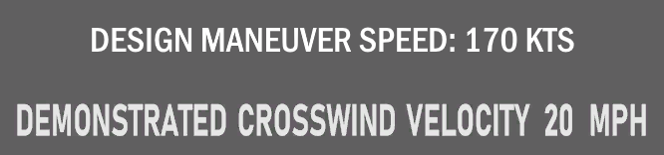
- Adjacent to mixture control:

- Adjacent to engine alternate air control;

- Adjacent to elevator trim control:

- Throttle quadrant:

- Adjacent to appropriate switches:
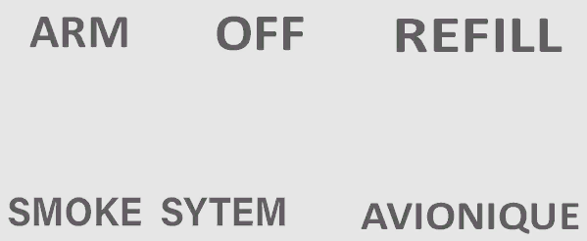
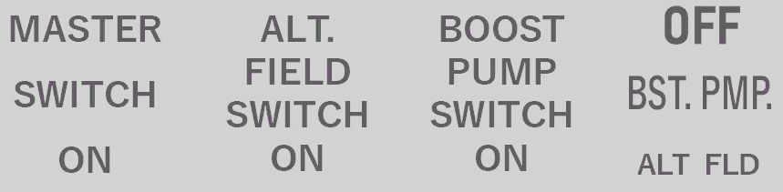
- Adjacent to appropriate circuit breakers:
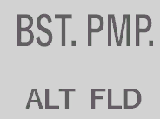
- On instrument panel:

- Adjacent to propeller governor control:

- Adjacent to cowl flap control:

- In view of pilot on cockpit fairing:

- In view of pilot on cockpit panel:


AIRSPEED LIMITATIONS
Airspeed Limitations and their operational significance are shown in Figure 2-1.
 | SPEED | MPH  CAS | KTS  CAS | REMARKS
V_{NE} | Never Exceed | 218 | 190 | Do not exceed in any operation.
V_{NO} | Normal operation | 172 | 150 | Do not exceed except in smooth air.
V_{A} | Maneuvering | 172 | 150 | Do not make full or abrupt control movements above this speed.
Figure 2-1 Airspeed Limitations

AIRSPEED INDICATOR MARKINGS
Airspeed Indicator markings and their color code significance are shown in Figure 2-2.
MARKING | AIRSPEED RANGE | SIGNIFICANCE
GREEN ARC | 40 TO 172 MPH  46 TO 150 KTS | Normal operating range. Lower limit is maximum weight VS at most forward C.G.. Upper limit is maximum structural cruising speed.
YELLOW ARC | 172 TO 218 MPH  150 TO 90 KTS | Operations must be conducted with caution and only in smooth air.
RED LINE | 219 MPH  191 KTS | Maximum speed for all operations.
Figure 2-2 Airspeed Indicator Markings

POWER PLANT LIMITATIONS
Engine Manufacturer: | Textron Lycoming
Engine Model Number: | AEIO-540-EXP
Engine Operating Limits for takeoff and continuous operations:
Maximum Power: | 315 BHP
Maximum Engine Speed: | 3000 RPM
Maximum Cylinder Head Temperature: | 500°F (260°C)
Maximum Oil Temperature: | 245°F (118°C)
Oil Pressure:  Minimum:  Maximum: | 25 PSI (1.7 bar)  100 PSI (6.89 bar)
Standard Propeller
Manufacturer: | Hartzell
Model Number: | HC-C3YR-4AX
Number of Blades: | 3 Composite
Diameter Maximum  Minimum | 80 inches (2.03 m)  78 inches (1.98 m)
Propeller Blade Angle at 30 in (76.2cm) Station
High:  Low: | 32° to 34°  11° + or - .1° @  30 inch station.
Optional Propeller
Optional propeller installed in new aircraft at Aviat Aircraft per TC, also for retrofit when installed in accordance with serialized Aviat Aircraft Kit.
Manufacturer: | MT-Propeller
Model Number: | MTV-9-B-C/C190-18a
Number of Blades: | 3 Composite
Diameter Maximum  Minimum | 75 inches (190 cm)  75 inches (190 cm)
Propeller Blade Angle at 26.18 in (6.5 cm) station
High:  Low: | 30° + or - 1°  13° + or - .2°

Note
For European operations only, in the interest of noise abatement or where local noise ordinances may apply the following RPM limitations should be followed:
“2700 RPM max takeoff for five minutes followed by a reduction to 2500 RPM, foe continuous cruise power”.

WARNING
It is the responsibility of the pilot to check on performance differences in Section 5 of this manual when the optional propeller is installed. *
* Note from the author: Section 5 will not be covered!

POWER PLANT INSTRUMENT MARKINGS
Power plant instrument markings and their color code significance are shown in Figure 2-3.
INSTRUMENT | RED LINE MIN. LIMIT | GREEN ARC NORMAL OPERATING | YELLOW ARC CAUTION RANGE | RED LINE MAX. LIMIT
TACHOMETER |  | 500 – 3000 RPM |  | 3000 RPM
OIL TEMPERATURE |  | 100°F (38°C) 245°F (118°C) |  | 245°F (118°C)
CYLINDER HEAD |  |  |  | 500°F (260°C)
FUEL PRESSURE |  | 0-9 PSI (0-.62 bar) |  | 9 PSI (.62 bar)
OIL PRESSURE | 25 PSI | 60 – 90 PSI | 25 – 60 PSI  90 – 100 PSI | 100 PSI
Figure 2-3 Power Plant Instrument Markings

WEIGHT LIMITS
Maximum Takeoff Weight: | 1325 lbs (601.0 kg)(Normal Category)
Maximum Landing Weight: | 1325 lbs (601.0 kg)(Normal Category)
Maximum Gross Weight: | 1325 lbs (601.0 kg)(Normal Category)  1250 lbs (567.0 kg)(Aerobatic Category)
Maximum Weight in Baggage Compartment: | 20 lbs (9.01 kg)

WARNING
NO AEROBATIC MANEUVERS WITH BAGGAGE.

CENTER OF GRAVITY LIMITS
Center of Gravity Range
Normal category
Forward: | FS 86.35 at 1125 lbs. or less, with straight line variation to FS 88.5 at 1325 lbs.
Aft: | FS 90.20 at 1325 lbs. or less

Aerobatic category
Forward: | FS 86.35 at 1125 lbs. or less, with straight line variation to FS 88.5 at 1250 lbs.
Aft: | FS 90.20 at 1250 lbs. or less

MANEUVER LIMITS
This airplane is certified in the normal category and the aerobatic category. The normal category is applicable to aircraft intended for non-aerobatic operations.
These include any maneuvers incidental to normal flying, stalls, lazy eights, chandelles, and steep turns in which the angle of bank is not more than 60°. The aerobatic category is applicable to aircraft intended for aerobatic operations. These include all maneuvers listed on the approved maneuvers and recommended entry speeds placard and listed in this flight manual.

FLIGHT LOAD FACTOR LIMITS
Normal Category | Positive +3.8 G., Negative -1.52 G.
Aerobatic Category | Positive +6.0 G., Negative -3.0 G.

KINDS OF OPERATIONS
This airplane must be operated as a DAY VFR airplane. FAR Part 91 establishes the minimum required instrumentation and equipment for these operations. The reference to types of flight operations on the operation limitations placard reflects equipment installed at the time of Airworthiness Certificated issuance.
Flight into known icing conditions is prohibited. In cold weather operation and freezing temperatures it is the pilot’s duty to make sure that the engine alternate breather is open.

KINDS OF OPERATION EQUIPMENT (KOEL)
Electrical Power |  | VFR DAY
1. | Battery | 1
2. | Alternator | 1
3. | Ammeter | 1
Fire Protection
1. | Firewall Fuel Shutoff Valve | 1
Flight Controls
1. | Trim Tab Indicator (Elevator) | 1
2. | Stall Warn Horn | 1
Fuel
1. | Fuel Quantity Indicator | 1
2. | Electric Fuel Boost Pump | 1
3. | Engine Fuel Flow Gauge | 1
4. | Upper Wing Fuel Tank Valve | 1
Ice and Rain Protection
1. | Alternate Static Air Source | 1
Navigation
1. | Sensitive Altimeter | 1
2. | Airspeed Indicator | 1
3. | Magnetic Compass | 1
Instruments
1. | “G” Meter (Aerobatic flight only) | 0
Engine Indicating
1. | Tachometer | 1
2. | Manifold Pressure Gauge | 1
3. | Cylinder Head Temperature Gauge (CHT) | 1
Engine Oil
1. | Oil Pressure Indicator | 1
2. | Oil Temperature Indicator | 1

- A zero (0) used in the above list means that the equipment and/or system was not required for type certification for that kind of operation.
- The above equipment list is predicated on a crew of one pilot.
- Equipment and/or systems in addition to those listed above may be required by the operating regulations.
- The above list does not include all specific instruments, communications and navigations equipment required by FAR Parts 91 and 135.

PAGE INTENTIONALY LEFT BLANK

Operational Checklists
Engine Failures
Engine Failure During Takeoff Run
Engine Failure Immediately After Takeoff
Engine Failure During Flight

Forced Landings
Emergency Landing Without Engine Power
Precautionary Landing With Engine Power
Ditching

Fires
During Start On Ground
Engine Fire In Flight

Inadvertent Icing Encounter

ELT Operation

Amplified Procedures
Engine Failure
Forced Landing
Landing without Elevator Control
Fires
Emergency Operations in Clouds
Flight in Icing Conditions
Static Source Blocked
Spins

Rough Engine Operation or Loss of Power
Icing
Low Oil Pressure

ELT Operation

INTRODUCTION
Section 3 provides checklist and amplified procedures for coping with emergencies that may occur. Emergencies caused by airplane or engine malfunctions are extremely rare if proper preflight inspections and maintenance are practiced. En rout weather emergencies can be minimized or eliminated by careful flight planning and good judgement when unexpected weather is encountered. However, should an emergency arise, the basic guidelines described in this section should be considered and applied as necessary to correct the problem. Emergency procedures associated with ELT and other optional systems can be found in Section 9.

SPEEDS FOR NORMAL OPERATIONS
Engine Failure After Takeoff: | 95 MPH (83KTS)
Maneuvering Speed: | 154 MPH (134KTS)
Maximum Glide Speed: | 95 MPH (83KTS)
Precautionary landing with Engine Power: | 95 MPH (83KTS)
Landing Without Engine Power: | 95 MPH (83KTS)

OPERATIONAL CHECKLIST

ENGINE FAILURES
ENGINE FAILURE DURING TAKEOFF RUN
1. | Throttle: | Idle
2. | Brakes: | Apply
3. | Mixture: | Idle Cut-off
4. | Ignition Switch: | Off
5. | Master Switch: | Off

ENGINE FAILURE IMEDIATELY AFTER TAKEOFF
1. | Airspeed: | 95 MPH (83KTS)
2. | Mixture: | Idle Cut-off
3. | Fuel Selector Valve: | Off
4. | Ignition Switch: | Off
5. | Master Switch: | Off

ENGINE FAILURE DURING FLIGHT
1. | Airspeed: | 95 MPH (83KTS)
2. | Fuel Selector Valve: | On
3. | Fuel Boost Pump: | On
4. | Mixture: | Rich
5. | Ignition Switch: | Both  (Start if propeller is stopped)

ENGINE FAILURES
EMERGENCY LANDING WITHOUT ENGINE POWER
1. | Airspeed: | 95 MPH (83KTS)
2. | Mixture: | Idle Cut-off
3. | Fuel Selector Valve: | Off
4. | Ignition Switch: | Off
5. | Canopy: | Jettison (at pilot’s option)
6. | Master Switch: | Off when landing is assured
7. | Touchdown: | Tail wheel first
8. | Brakes: | Apply as needed but control the aircraft.

PRECAUTIONARY LANDING WITH ENGINE POWER
1. | Airspeed: | 95 MPH (83KTS)
2. | Selected Field: | Fly Over,  noting terrain and obstructions,  then upon reaching a safe  altitude and airspeed.
3. | Electrical Switches: | Off
4. | Airspeed: | 95 MPH (83KTS)
5. | Canopy: | Jettison (at pilot’s option)
6. | Master Switch: | Off
7. | Touchdown: | Tail wheel first
8. | Ignition Switches: | Off
9. | Brakes: | Apply as needed but control the aircraft.

DITCHING
1. | Radio: | Transmit Mayday on 121.5 mhz,  giving location and intentions
2. | Power: | Establish 300 ft/min descent  at 95 MPH (83KTS).
3. | Approach: | High Winds, Heavy seas  INTO WIND  Light Wind, Heavy Swells,  PARALLEL TO SWELLS.
4. | Canopy: | Jettison
5. | Touchdown: | Level Attitude at established descent.
6. | Airplane | Evacuate

FIRES
DURING START ON GROUND
1. | Cranking: | Continue to crank the engine  in an attempt to start the engine  and use any fuel in the lines.  Do not use the boost pump.  Leave the MIXTURE  control in idle cutoff  and set the fuel selector  to OFF.
2. | Mixture: | Idle Cut-off
3. | Fire Extinguisher: | Obtain (have ground attendants obtain)
4. | Engine: | Secure
 | A. Master Switch: | Off
 | B. Ignition Switch: | Off
 | C. Fuel Selector: | Off
5. | Fire: | Extinguish using fire extinguisher, wool blanket, or dirt
6. | Fire Damage: | Inspect, repair  or replace damaged components or wiring before conducting flight.

ENGINE FIRE IN FLIGHT
1. | Mixture: | Idle Cut-off
2. | Fuel Selector Valve: | Off
3. | Master Switch: | Off
4. | Airspeed: | 95 MPH (83KTS)  (If fire is not extinguished,  increase glide speed to find  an airspeed which will  provide an incombustible mixture.  If fire is not extinguished and you have a parachute jettison canopy and leave aircraft if you have proper altitude.)
5. | Forced Landing: | Execute  (as described in Emergency Landing Without Engine Power).

ELECTRICAL FIRE IN FLIGHT
1. | Master Switch: | Off
2. | All Avionic Switches: | Off
3. | Vents/Cabin Air: | Closed
4. | Fire Extinguisher: | Activate  (if available)

WARNING
After discharging an extinguisher within a closed cabin, ventilate the cabin.
If fire appears out and electrical power is necessary for continuance of flight:
6. | Master Switch: | On
7. | Circuit Breakers: | Check for faulty circuit,  do not reset.
8. | Radio/Electrical Switches: | On one at a time,  with delay after each  until short circuit is localized.
9. | Vents/Cabin Air: | Open when it is ascertain that  fire is completely extinguished.

INADVERTENT ICING ENCOUNTER
- Turn back or change altitude to obtain an outside air temperature that is less conducive to icing.
- Increase engine speed to minimize ice build-up on propeller blades.
- Watch for signs of air intake ice and apply alternate air as required. An unexplained loss in manifold pressure could be caused by air intake screen ice.
- Plan a landing at the nearest airport.
- With any ice accumulation on the wing leading edges, be prepared for significantly slower stall speed.
- Approach at 110 to 115 mph depending upon the amount of ice accumulation.
- Touchdown tail wheel first.

INADVERTENT ICING ENCOUNTER
(Erroneous Instrument Reading Suspected)
1. | Alternate Static Source Valve | ON
2. | Airspeed: | Consult placard and AFM Sect 2.
3. | Altitude: | Consult placard and AFM Sect 2.
WARNING
BEFORE ANY FLIGHT INTO TEMPERATURES BELOW FREEZING CHECK THAT THE ENGINE ALTERNATE BREATHER HOLE IS OPEN AND CLEAR OF OIL OR OTHER FOREIN MATERIAL.

AMPLIFIED PROCEDURES

Will be added in a later version!

PAGE INTENTIONALY LEFT BLANK

INTRODUCTION
Section 4 provides checklist and amplified procedures for the conduct of normal operation. Normal procedures associated with optional systems can be found in Section 9.

SPEEDS FOR NORMAL OPERATIONS
Unless otherwise noted, the following speeds are based on a maximum weight of 1325 lbs (601.0 kg) and may be used for any lesser weight.
Takeoff
Normal Climb Out: | 100 MPH (87KTS)

En route Climb
Normal: | 120 MPH (104 KTS)
Best Rate: | 95 MPH (83 KTS)
Best Angle: | 82 MPH (71 KTS)

Landing Approach
Normal Approach: | 95 MPH (83 KTS)
Short Field Approach: | 95 MPH (83 KTS)

Balked Landing
Maximum Power: | 95 MPH (83 KTS)

Maximum Demonstrated Crosswind Velocity
Takeoff or landing: | 20 MPH (17 KTS)

Demonstrated flight-time inverted is: | 10 minutes

Engine inverted oil system operation
Refer to the Textron Lycoming Operator’s manual.

CHECKLIST PROCEDURES
PREFLIGHT INSPECTION
COCKPIT
1. | Control locks: | Remove (if installed)
2. | Ignition Switch: | Off
3. | Master Switch: | Off
4. | Seat Belt: | Check for Wear and security
5. | Loose items: | Secure or remove for aerobatics
6. | Baggage: | Secure
7. | Baggage Door: | Closed and Secure
8. | Battery: | Secure and no leaks
9. | Parking Brake: | On

EMPENAGE
1. | Fabric: | No holes, general condition
2. | Tail surfaces: | Secure and general condition
3. | Tail wheel & springs: | Secure and general condition
4. | Tie-Down: | Disconnect
5. | Control Surfaces: | Check freedom of movement and security
6. | Aux Tank Valve Drain: | Drain, check for water and sediment

RIGHT WINGS
1. | Fabric: | No holes, general condition
2. | Aileron: | Check freedom of movement and security
3. | Spade: | Check security
4. | I Strut: | Check security
5. | Stall Vane: | Check operation
6. | Flying Landing Wires: | No Nicks, and secure
7. | Tie down: | Disconnect

NOSE
1. | Main wheels: | Proper inflation, wear
2. | Brakes: | Security and line clearance
3. | Alternate Engine Breather Hole: | Open and clean
4. | Propeller and Spinner: | No Nicks, secure and no oil leaks
5. | Air Inlet Screen: | Check for restrictions
6. | Engine Oil Level: | Check; do not operate with less then 9 quarts. Fill to 12 quarts for extended flight
7. | Main Fuel Strainer: | Drain, check for water and sediment

LEFT WINGS
1. | Pitot tube:
2. | Flying Landing Wires: | No Nicks, and secure
3. | I Struts: | Check security
4. | Aileron: | Check freedom of movement and security
5. | Spades: | Check security
6. | Fabric | No holes, general condition
7. | Tie down: | Disconnect

BEFORE STARTING ENGINE
1. | Preflight Inspection: | Complete
2. | Canopy: | Closed and locked
3. | Seat Belts/Shoulder Harnesses: | Adjusted and locked
4. | Brakes: | Test and on
5. | Cowl Flaps: | Open
6. | Circuit Breakers: | In

STARTING ENGINE
COLD START
1. | Mixture: | Rich
2. | Propeller: | High RPM
3. | Throttle: | ¼ open
4. | Master Switch: | On
5. | Boost Pump: | On, 2-3 sec Max
6. | Mixture: | Idle cut off
7. | Starter Switch: | On (Start)
8. | Mixture: | When engine starts, move mixture control slowly and smoothly to Full Rich
9. | Oil Pressure: | Check
10. | Alternator Field Switch | On

HOT START
1. | Mixture: | Idle cut off
2. | Propeller: | High RPM
3. | Throttle: | ½ open
4. | Master Switch: | On
5. | Starter Switch: | On (Start)
6. | Mixture: | When engine starts,  move mixture to Full Rich
7. | Oil Pressure: | Check
8. | Alternator Field Switch | On

BEFORE TAKEOFF
1. | Canopy: | Check locked
2. | Brakes: | Set
3. | Flight Controls: | Free and correct
4. | Flight Instruments: | Set and correct
5. | Fuel Selector: | On
6. | Mixture: | Rich if bellow 5000 feet MSL, lean as required above 5000 feet MSL.
7. | Elevator Trim: | Takeoff neutral
8. | Throttle: | 1700 RPM check:
 | a: Propeller: | Cycle from high to low RPM,  return to high RPM (full in)
9. | Throttle: | 2200 RPM Check:
 | a: Magnetos: | Check (RPM drop should not exceed 175 RPM on either magneto or 60 RPM differential between magnetos)
 | b: Engine Instruments: | Check
 | c: Ammeter: | Check
10. | Avionics: | On and set

TAKEOFF
1. | Power: | Full Throttle 2800 RPM
2. | Elevator Control: | Lift tail
3. | Rotate: | 74 MPH (64 KTS)
4. | Climb Speed: | 100 MPH (87 KTS)
5. | Power: | As required or desired

EN ROUTE CLIMB
1. | Airspeed: | 120 MPH (104 KTS)
2. | Power: | As required or desired
3. | Mixture: | Rich or lean as  needed for required power
4. | Cowl Flaps: | Open as required for cooling

CRUISE
1. | Power: | 20-24 Inches Hg, 2200 – 2400 RPM  (no more than 75% power)
2. | Elevator Trim: | Adjust
3. | Mixture: | Lean
4. | Cowl Flaps: | Closed or as needed for cooling

DESCENT
1. | Power: | As desired
2. | Mixture: | Enrichen as required
3. | Cowl Flaps: | Closed or as needed for cooling

BEFORE LANDING
1. | Seat Belts/Shoulder Harnesses: | Adjust lock
2. | Fuel selector: | Check on
3. | Mixture: | Rich below 5000 feet MSL
4. | Propeller: | High RPM

LANDING
NORMAL LANDING
1. | Airspeed: | 95 MPH (83 KTS)
2. | Trim: | Adjust
3. | Touchdown: | Tail wheel first
4. | Elevator Control: | Full back (up elevator)
5. | Braking | Minimum required

BALKED LANDING
1. | Power: | Full Throttle (2800 RPM)
2. | Climb Speed: | 95 MPH (83 KTS)
3. | Cowl Flaps: | Open

AFTER LANDING
1. | Cowl Flaps: | Open

SECURING AIRPLANE
1. | Throttle: | Idle
2. | Avionics: | Off
3. | Mixture: | Idle cut off
4. | Ignition Switch: | Off
5. | Master Switch: | Off
6. | Alternator Field Switch: | Off
7. | Aircraft: | Tie down or Secure

AMPLIFIED PROCEDURES

Will be added in a later version!

PAGE INTENTIONALY LEFT BLANK

